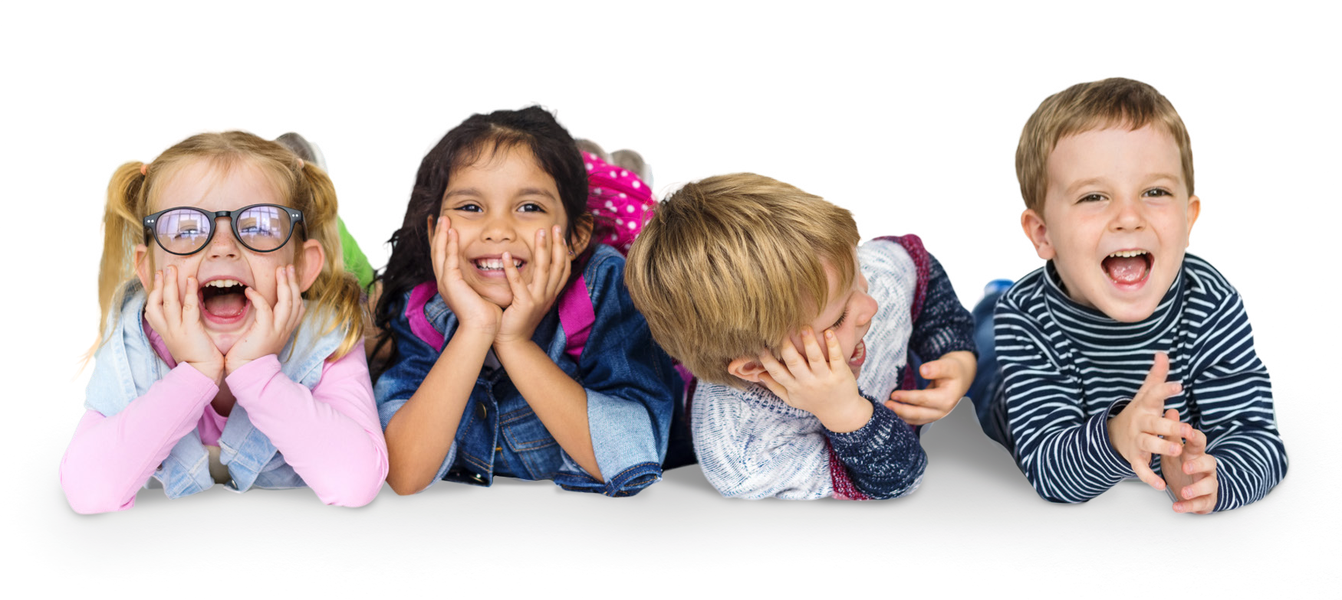The Child Safe Standards

The Child Safe Standards recommended by the Royal Commission into Institutional Responses to Child Sexual Abuse provide a framework so organisations can create cultures and adopt strategies to keep children safe from harm.

They:
ehceulpltduraivl change in organisations earprinciple-based and outcome-focused
earflexible enough that they can be adapted by organisations of varying sizes and characteristics vaoid placing undue burden on organisations ghaenlpisaotrions address multiple risks
ebcaalauntcion and caring
eara benchmark against which organisations can assess their child safe capability and set performance targets earof equal importance and are interrelated

For more information on the Child Safe Standards or to arrange an information session please visit www.ocg.nsw.gov.au, contact childsafe@ocg.nsw.gov.au or phone 02 9286 7225

The Child Safe Standards

STANDARD 1:
Child safety is embedded in organisational leadership, governance and culture

STANDARD 2:
Children participate in decisions affecting them and are taken seriously

STANDARD 3:
Families and communities are informed and involved

STANDARD 4:
Equity is upheld and diverse needs are taken into account

STANDARD 5:
People working with children are suitable and supported

STANDARD 6:
Processes to respond to complaints of child abuse are child focused

STANDARD 7:
Staff are equipped with the knowledge, skills and awareness to keep children safe through continual education and training

STANDARD 9:
Implementation of the Child Safe Standards is continuously reviewed and improved

STANDARD 8:
Physical and online environments minimise the opportunity for abuse to occur

STANDARD 10:
Policies and procedures document how the organisation is child safe1

ISBN: 978-0-6451877-6-2

